Exp 3 : ARM Assembly – Computations in ARM

Target : To learn basics of ARM instructions and write a program in assembly language for given problems.

Tasks :

1. Compute the factorial of a given no.
2. Combine the low four bits of each of the four consecutive bytes beginning at LIST into one 16-bit halfword. The value of at LIST goes into the most significant nibble of the result store the result in 32 bit variable RESULT.
3. Given a 32-bit number, identify whether it is even or odd.

Code :

1)

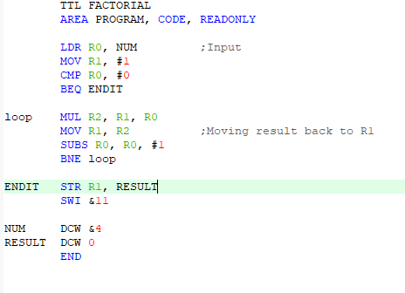

In this program It computes the factorial of ‘4’. It computes by repeated multiplication and increment if the number until the desired result is obtained.

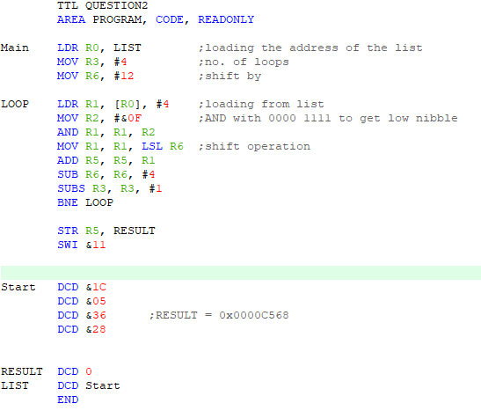2)

The result required is obtained by bit manipulation i.e shift operations. The lowest nibble of the first no. is shifted 12 times and second no. 8 times and so on.

3)

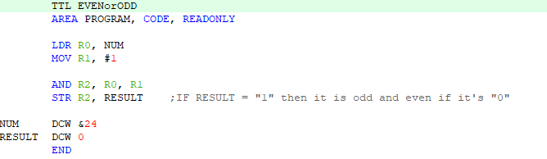

The input undergoes AND operation with 1 and if the result is ‘1’ then the input is odd and even if the result is ‘0’.

Conclusion :

* Learnt about the basic instruction set in ARM processors.
* How bit manipulation is done in ARM
* Computational advantages in ARM compared to AVR